GREENING BUSINESS
ECODESIGN AND ENERGY LABELS
A GUIDE TO ENERGY LABELS

Document information:
Activity result: | A5 Development of educational tools for greening businesses
Document type: | Training material
Responsible partner: | Centre for the Development of Jablanica and Pcinja Districts Leskovac, Serbia
Dissemination level: | Public

Document history:
Version | Date | Description /Comments | Author(s)
Version 1.0 | 04.02.2025. | Draft | - PMT
Version 2.0 |  | Final version | - PMT

Disclaimer:
Funded by the European Union. Views and opinions expressed are however those of the author(s) only and do not necessarily reflect those of the European Union or Foundation Tempus. Neither the European Union nor the granting authority can be held responsible for them.

ECODESIGN AND ENERGY LABELS

Energy efficiency is a strategic priority for the European Union (EU). Using energy and materials more efficiently can reduce the demand for energy and resources, leading to lower energy bills for consumers and businesses, and lower emissions of greenhouse gases and other pollutants. Ecodesign of products is a set of conditions that an energy-using product must meet in terms of environmental protection during the period covering the processes of its creation, use and disposal. Ecodesign is one of the fundamental concepts of the circular economy model, which envisages that products are designed in such a way as to maximise their lifespan, throughout all stages of the life cycle: from the extraction of raw materials from nature, the production of materials and components of the product, through its use and maintenance, to end-of-life treatment — reuse, dismantling, recycling, energy recovery, and final disposal.

Ecodesign and labelling are key tools for increasing the energy efficiency of products and the efficiency of materials. The Ecodesign and Energy Labelling Regulation is directly and consistently applicable to the EU market. This regulation sets minimum requirements for the energy efficiency and other environmental performance of products, such as electrical appliances, Information and Communication Technologies (ICT) products, industrial machinery or tyres. Manufacturers are encouraged to develop new technologies to maximise energy efficiency while minimising waste. Serbia and North Macedonia are required to align their legislation with the Ecodesign and Energy Labelling Regulations. Both countries have adopted or are in the process of adopting regulations in the field of energy labelling of products, which set out the obligations of suppliers and retailers regarding the labelling, appearance and content of the energy label. Understanding product efficiency labelling is key to greening your small and medium-sized enterprises (SMEs) business because purchasing a more energy-efficient appliance or product saves money and protects the environment. The energy efficiency label is a standard, recognisable label that provides a potential buyer with essential information about the product and, above all, visually indicates which energy efficiency class the product belongs to.

Figure 1: General appearance and content of the energy label

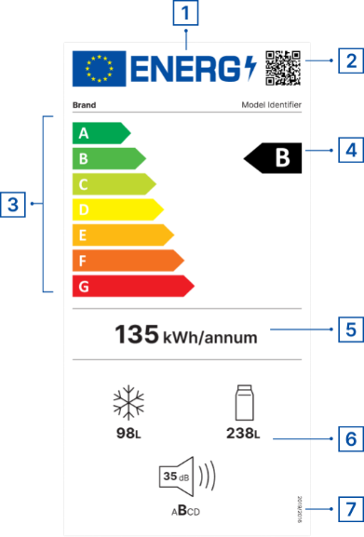 | - Language neutral logo. The bolt replaces the last letter in the word ENERG stands for a meaning that varies in different EU languages (e.g. Energy, Energie, Energia, Energía, Énergie, Energija, Enerģija, Energi, etc.).  - QR code with a link to the European Product Registry for Energy Labelling (EPREL).  - Energy efficiency classes (with a scale from A to G).  - The energy efficiency class of this product model.  - Energy consumption (e.g. kWh per year).  - Overview of additional non-energy parameters (pictograms: noise emission, water consumption, capacity, repairability, reliability class, etc.).  - Reference to regulation (EU regulation number).

The introduction of new European Union regulations has led to a change in the range of product energy classes and energy labels. The new energy efficiency labelling on products ranges from "A" to "G" classes.
"A" represents the most efficient energy class, while "G" is the least efficient class. In practice, this means that a "G" class appliance consumes twice as much electricity per year as those marked with class "A". A significant change is the introduction of QR codes in the upper right corner of the energy label. Scanning the QR code accesses the EPREL database on products marked with the energy efficiency label. This database guarantees the quality, reliability and usefulness of information on the product model and its specific characteristics. Suppliers must register all products with energy labels when placing them on the EU market. Depending on the type of appliance or product, the pictograms of additional non-energy parameters and the number of the EU regulation vary. The labels of individual appliances and products used by SMEs in their work will be shown below.

Figure 2: Appearance and content of the energy label of electric light sources

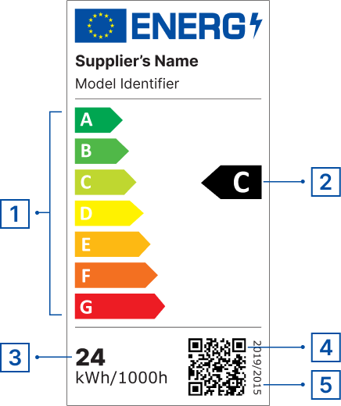 | - Energy efficiency class scale from A to G.  - The energy efficiency class of this product.  - Energy consumption of the light source in on mode, expressed in kWh of electricity consumption per 1,000 hours.  - QR code with a link to the EPREL database.  - Regulation (EU) No. 2019/2015.

Figure 3: Appearance and content of the energy label for electronic displays
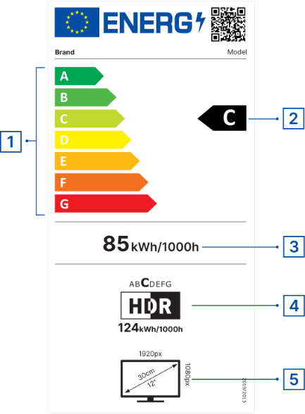 | - Energy efficiency class scale from A to G for standard dynamic range (SDR).  - The energy efficiency class of this product for standard dynamic range (SDR).  - Power consumption for standard dynamic range (SDR) for 1000 hours (kWh).  - High Dynamic Range (HDR) power consumption for 1000 hours (kWh) and HDR efficiency class.  - Screen dimensions (in cm and inches), horizontal and vertical resolution (in pixels).

Figure 4: Appearance and content of the energy label for smartphones and tablets (application from 20.06.2025)

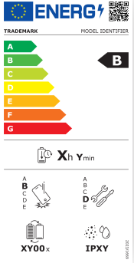 | Labels for smartphones and tablets must include information on their energy efficiency, battery longevity, dust and water resistance, and drop resistance, as well as a repairability rating. Batteries for these devices must withstand at least 800 charge and discharge cycles while retaining at least 80% of their initial capacity. Manufacturers are required to make critical spare parts available to repairers within 5-10 working days, and up to 7 years after the product model has been discontinued on the EU market. They must also ensure that the operating system can be upgraded for at least 5 years after the date of cessation of marketing.

Figure 5: Appearance and content of the energy label for commercial refrigerators
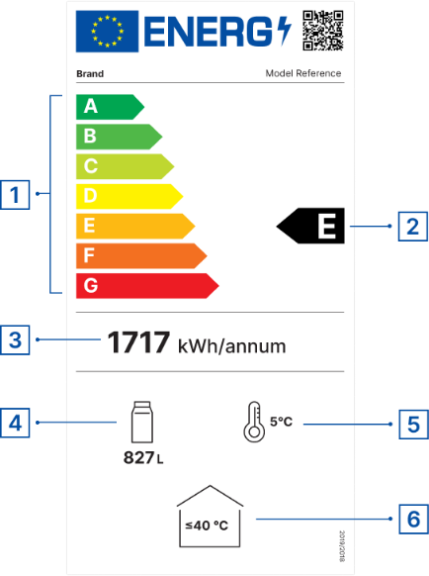 | 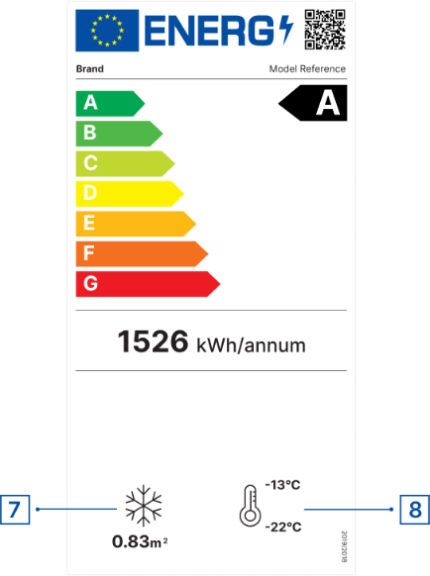 | - Energy efficiency class scale from A to G.  - The energy efficiency class of this product.  - Annual electricity consumption (kWh).  - Gross volume of the refrigerator compartment in litters.  - Operating temperature of the refrigerator compartment °C.  - Maximum ambient temperature °C.  - Net volume of the frozen compartment in litters.  - Operating temperature of the freezer compartment in °C.
Figure 6: Appearance and content of the tire energy label
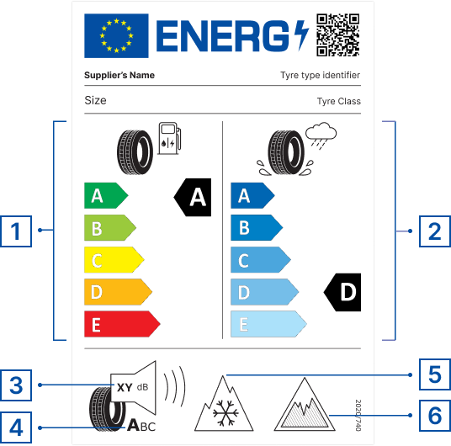 | - Rolling resistance class from A to E (the higher the class, the lower the fuel consumption).  - Wet grip class from A to E.  - External rolling noise level.  - External rolling noise class (A to S).  - Tire for severe snow conditions.  - Tire for severe ice conditions.

Figure 7: Appearance and content of the dishwasher energy label
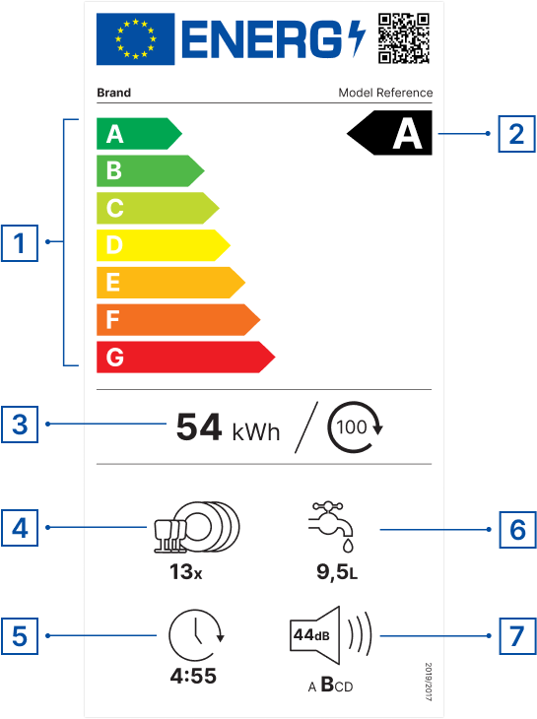 | - Energy efficiency class scale from A to G.  - The energy efficiency class of this product.  - Electricity consumption for 100 washing cycles in eco mode (kWh).  - Capacity expressed in the number of standard place settings using the eco program.  - Duration of the eco program (in hours and minutes).  - Water consumption per eco program cycle (in litters).  - Noise level in decibels (dB) and noise level class.

Figure 8: Appearance and content of the washing machine energy label

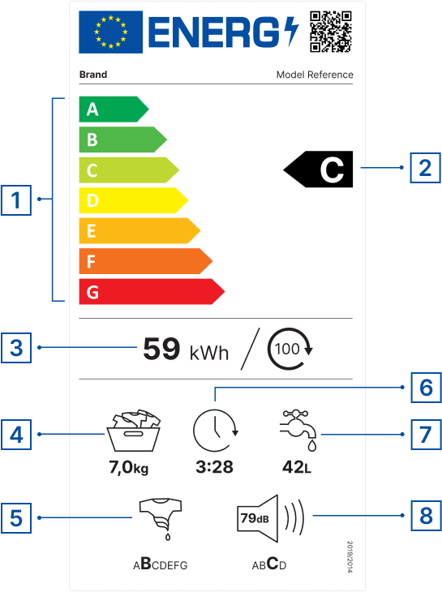 | - Energy efficiency class scale from A to G.  - The energy efficiency class of this product.  - Electricity consumption for 100 washing cycles in eco mode (kWh).  - Wash cycle capacity (kg).  - Centrifugation efficiency class.  - Duration of the washing and drying cycle at the declared capacity (in hours and minutes).  - Water consumption per cycle (in litters).  - Noise level in decibels (dB) and noise level class.

Ecodesign and energy labelling requirements apply to a wide range of electrical appliances and equipment. Air conditioners are supplied with an energy label indicating their energy efficiency. This label includes information on the energy rating of the cooling and heating functions and an indication of the hourly or annual energy consumption, as well as noise levels. The requirements apply to air conditioners with a declared capacity of less than or equal to 12 kW for cooling (or heating if there is no cooling function) and to fans with an electric fan input power less than or equal to 125 W.

Ecodesign requirements for solid fuel boilers with a declared heat output of 500 kW or less are mandatory from 2020 for all manufacturers and suppliers wishing to sell their products in the EU. These requirements also apply to boilers that are part of a package consisting of a solid fuel boiler, additional heaters, temperature controls and solar devices. The requirements cover energy efficiency and emissions of air pollutants. For air conditioners and solid fuel boilers, the old labels apply. EPREL offers more detailed information on models placed on the EU market. The database provides additional information such as sound power, heating efficiency for 3 different climates, cooling efficiency, annual electricity consumption, design load in heating and cooling mode, and type of refrigerant. This database also contains data for solid fuel boilers, heating, cooling and ventilation equipment, production equipment (electric motors, industrial fans, power transformers, water pumps, welding equipment, etc.).

Figure 9: Appearance and content of the energy label for air conditioners

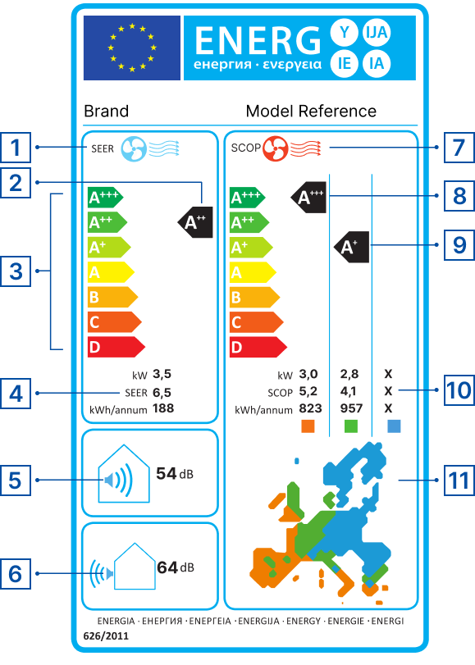 | - Blue fan cooling energy efficiency ratio (SEER).  - The energy efficiency class of this cooling product.  - Energy efficiency class scale from A + ⁺⁺ to D.  - Designed load in kW. Seasonal energy efficiency ratio. Annual energy consumption in kWh for cooling.  - Indoor noise level (dB).  - External noise level (dB).  - Red fan seasonal coefficient of performance for heating (SCOP).  - Energy efficiency class of this product for heating in the warm season.  - The energy efficiency class of this heating product in an average season.  - Heating mode: designed load in kW, up to 3 heating seasons. Annual energy consumption in kWh for heating.  - European map showing heating seasons and corresponding coloured squares.

Figure 10: Appearance and content of the energy label for solid fuel boilers

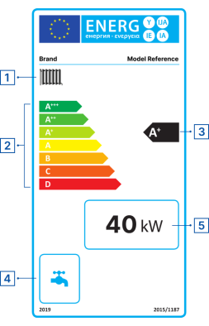 | - Space heating function.  - Energy efficiency class scale from A + ⁺⁺ to D.  - The energy efficiency class of this product.  - Water heating function.  - Declared heat output in kW.

Figure 11: Appearance of other energy labels

Ovens | Hoods | Boilers

Source:
European Commission. Ecodesign and Energy Label

https://energy-efficient-products.ec.europa.eu/ecodesign-and-energy-label_en

European Commission. EPREL

LABEL 2020 TOOLS

https://www.label2020.eu/

1 Inch (1“)=2.54cm

